

**LORAWAN PROJECT**

By:

Devomech Solutions Pvt. Ltd.

Date: 14-04-2023

# Current Progress:

* Written the logic for the input and output signals at home and field site nodes.
* Tested the two way communication on both Arduino Uno as well as Arduino mega boards with the shields.

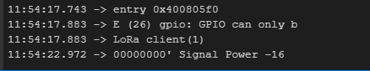

Figure 1 Client Node

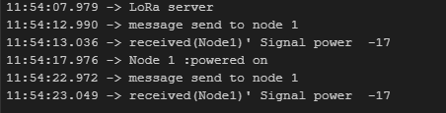

Figure 2 Server Node

# Task for Next Week

* Test the code with hardware interfaced on both client and server side.
* Optimize the payload/code if the system faces the low range transmission problems.